**The solutions are provided in another file but I will recommend you to solve this small exercise by yourself to boost your confidence.**

**Also please note your way of solving the query can be different from my way of solving the query but that is ok because a single query can be solved in many different ways.**

**Note : Please use the EmployeeDetails Table for solving this demo.**

**In case you have not created this table yet I am still sharing the script with you. So that you can copy paste in SSMS and create this table.**

CREATE TABLE [dbo].[EmployeeDetails](

[Emp_No] [int] NOT NULL primary key,

[Name] [varchar](50) NULL,

[DOB] [varchar](50) NULL,

[Gender] [char](10) NULL,

[Salary] [int] NULL,

[City] [varchar](20) NULL,

)

INSERT

INTO EmployeeDetails(Emp_No, Name, DOB, Gender, Salary, City)

VALUES (100,'Mahesh','1965-12-01','Male',30000,'Delhi'),

(101,'Suresh','1963-11-14','Male',34000,'Delhi'),

(102,'Rajat','1969-12-21','Male',23000,'Shimla'),

(103,'Kalpana','1961-12-01','Female',40000,'Goa'),

(104,'Neha','1971-12-01','Female',19000,'Goa'),

(105,'Sunita','1958-12-01','Female',50000,'Delhi')

Questions

1. You need to provide the average salary based on the Gender

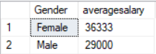

select Gender, AVG(Salary)

from EmployeeDetails

group by Gender

1. You need to display those cities which has TotalSalary of all the employees greater than 50000

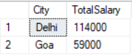

select City,SUM(Salary) TotalSalary

from EmployeeDetails

group by City

having sum(Salary) > 50000

1. You need to display Gender Wise Average Salary based on each City

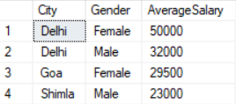

select City,Gender,AVG(Salary) AverageSalary

from EmployeeDetails

group by City,Gender